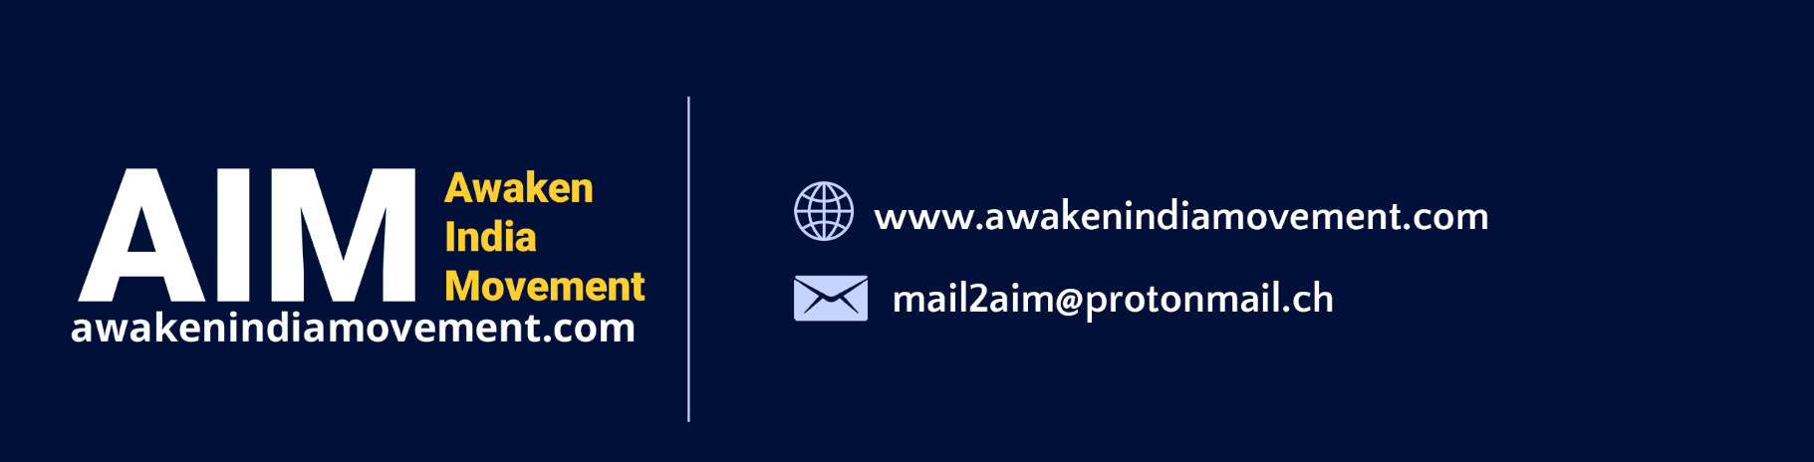

To, Date:

Dear Sir / Madam,

Subject: World Health Organization and its proposed ‘Global Pandemic Treaty’

We draw your attention to the World Health Organization and the Global Pandemic Treaty that is being formulated by it, with participation from Indian Government and the negotiations that are being held for its formulation. We, the undersigned, have collated serious objections of the people of India to the whole idea of ‘Global Pandemic Treaty’ and the role being envisaged to an unelected organization, namely World Health Organization (WHO) and its proposed ‘First Draft’ of the treaty in the following 17 page document. We believe it primarily encroaches upon the rights of Indian citizens as enshrined in the Indian Constitution.

This proposed ‘First Draft’ is violative of Article 14, 19 and 21 of the Constitution of India. It is against the law of Informed Consent as laid down by the Government of India under Disaster Management Act, 2005 itself, and it attempts to give sweeping powers to WHO, violating the sovereignty of India. The WHO is an unelected body and its provisions would also be ‘Ultra Vires’ of the Indian Constitution.

Our overall submission is as follows:

- Review all the omissions and blunders made by the Indian Government and Premier Medical Institutions, by unquestionably implementing WHO’s faulty medical protocols. These protocols implemented as part of the Covid Pandemic Response were based on misleading science and data, which consequently damaged public health and also claimed the lives of millions of Indians.

- Given that the WHO and other global bodies are warning of an impending pandemic, it is time India developed its own preventive, preparedness and responsive mechanisms. Towards this, we want the Indian government to facilitate the formation of a multi-disciplinary national level apex medicine and health committee, supported by state committees having adequate representation of accomplished healthcare practitioners from all fields of medicine and healthcare, as suggested by the public.

- We want Indian government to quit the WHO in order to pursue an independent medical care system that is also free of lobbying by private groups headed by Bill and Melinda Gates Foundation.

- We strongly advise urge Indian government not to sign WHO’s ‘Global Pandemic Treaty’ in haste, and without going through a public consultation and Parliamentary scrutiny process. We want a draft text to be examined by the apex multi-disciplinary national level medicine and health committee. Ultimately, the draft treaty has to be ratified by the Parliament. Only upon this ratification, Indian government can sign the Treaty.

- We do not want international organizations and global private groups and companies to dictate the future of Indian public health systems, policies and objectives.

We look forward to your timely and adequate response to these recommendations and also those incorporated in the 17-page document attached to this. Preparedness will help in avoiding suffering of ordinary citizens of India.

Thank You,

Yours Faithfully,

For Team, Awaken India Movement

And Others

